
CHANDAN TUMULU
Contact: +91 – 8095679888 , 9353395392 ~ E-Mail:chandan.tumulu@yahoo.com

Aiming for middle managerial level assignments in Sales & Marketing/ Business Development with an organisation of repute, preferably in Real Estate sector

PROFILE SUMMARY

- Nearly 15 years’ experience in areas of Sales & Marketing, Business Development, Dealership Management and Client Relationship Management
- Proven abilities in overseeing market forecasting and identifying & formulating the strategies to exploit business opportunities
- Proficient at maintaining cordial relationships with customers and ensuring quality & service norms to achieve greater customer satisfaction as well as business retention
- Expertise in developing & implementing promotion plans and organising events to enhance brand visibility
- Skilled in leading team members to ensure efficiency in service operations and meeting of individual & group targets

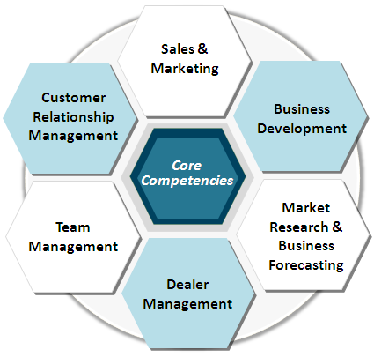

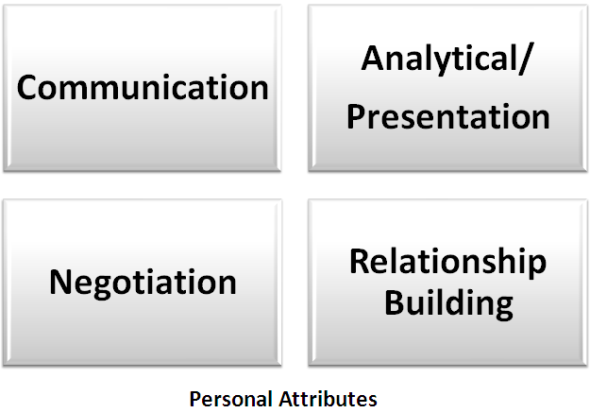

CORE COMPETENCIES

- Strategizing & implementing business directions, ensuring profitability in line with organisational objectives
- Handling sales & marketing operations in the assigned territory; conducting effective negotiations to secure & finalize orders, thereby achieving increased sales growth across region
- Conducting competitor analysis by keeping abreast of market trends & competitors’ moves to achieve market share metrics
- Providing market intelligence feedback to the product team for product enhancement
- Identifying and appointing key dealers and assisting the Dealer Team to expand their network in the assigned area
- Managing customer centric operations and ensuring customer satisfaction by achieving delivery & service quality norms
- Cultivating relations with key clients for suggesting most viable product range and securing repeat business
- Recruiting teams, imparting /organizing training programmes on the safe practices in SOPs and ensuring adherence to the environment standards for achieving pre-planned business targets

ORGANISATIONAL EXPERIENCE



Since: Jan 2022 To Dec 2023 Zonal Head

- Act as head of their respective zones and are answerable to the higher management about the business activities in that zone .

- Develop strong strategic sales plan and executing them effectively with right tactics to support both short term and long-term growth of the company.
- Developed a daily schedule of productive activity from creative sources and qualified lead. Arranging meetings with clients and taking them through property sites .
- Present the sales proposal, explaining the problems identified and the propose solution Close the sale and achieved assigned sales performance objective .
- Maintain current knowledge regarding competitor, sales process, and administrative process.

Since: Apr 17 to Jan 2022 Channel Partner (Own)

Key Result Areas :
- Resale Properties, Ready to move in projects and Rental.
- Developing relations with potential reality buyers and investors for various residential layouts and apartments.
- Research and survey of price of the property as per location.
- Lead generation from various sources like reference,portals,existing owners,etc
- Ensuring the documentation and paper work to be completed.
- Following up with banks,payments,agreements,documents and registration.

Since: Feb 16-Mar 17 Arvind Infrastructure LTD, Bangalore As Manager –Sales and marketing
 Key Result Areas :
- Team Handling with objectives setting and performance monitoring.
- Strategic sales planning
- Ensuring the strong presence of company’s customer base.
- Presentation of sales and budget reports.
- Handling channel partners.
- Average 50 sales in a quarter with a team of 7.
- Closely monitoring the lead generation and conversion with the team.

Since: July 15-Dec 15 Vandana Infrabuild PVT LTD , Bangalore As Manager –Sales

Key Result Areas :
- Motivating and leading a team of 4 executives to continuously achieve sales targets.
- Doing market survey on various builders & competitors.
- Coordinating with event managers and advertising agencies.

Since: JAN 15-MAR15 Bren Corporation, Bangalore As Deputy Manager –Sales

Key Result Areas : Handling Calls , Handling team, Fixing Site visit, Attaining Client, Convincing Client, Maintaining MIS, Coordinating with bank , Resolving Client Query, Documentations ,etc

SINCE: Aug’11-Dec‘14: Golden Gate Properties Limited, Bangalore as Deputy Manager - Sales



Growth Path: Joined as Senior Executive in Aug’11, promoted as Assistant Manager in Aug’12 and rose to the post of Deputy Manager – Sales in Aug’13 till Dec 15
Key Result Areas :

- Developing relations with potential reality buyers & investors for various residential layouts & apartments
- Interfacing with Clients, In-House Legal Department & CRM Department for post-sales activities
- Accountable for arranging the loans for customers as well as liaising with various banks
- Highlight:
- Recognized for overachieving team & individual sales targets by 150% through development of lead generation activities
- Took measures to attain customer satisfaction levels

SINCE: Jun’10 – Jul’11: Pratham Motors Pvt. Ltd., Bangalore (Dealers of Maruti Suzuki) as Sales Consultant-Corporate

Key Result Areas :
- Focussed on ensuring 100% customer satisfaction while handling sales of high value products
- Undertook visits to customer sites and analyzed field failures/ customer complaints & provided recommendation

PREVIOUS EXPERIENCE

Oct’08 - May’10: ACE Agency, Bangalore (Dealers of Vodafone), Bangalore as Business Development Executive
Apr’00 - Oct’08: Laxmi Electronics, Orissa (Dealers of Electronics Spare Parts) as Marketing Executive

IT SKILLS

- Well versed with MS Office and Internet Applications


EDUCATION

- Bachelors in Computer Application from Berhampur University, Berhampur in 2007
- 12th from Roland Supriya Junior College, Berhampur, Orissa Board in 2004
- 10th from City High School, Berhampur, Orissa Board in 2002

EXTRAMURAL ENGAGEMENTS

- Served as a part of school NCC Camp and carried out firing activities
- Involved in organizing Blood Donation Camps during college
- Actively took part in various cricket matches and running race during school/ college

PERSONAL DETAILS

Date of Birth : 1st March 1982
Permanent Address : Flat no. 1107, Alston, SJR Blue Waters, Silver County Road, Hosa Road, Bangalore - 68
Languages Known : English, Hindi, Kannada, Oriya and Telugu
Location Preference : Bangalore

