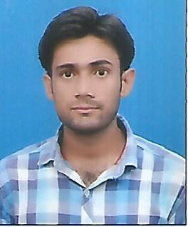
RAHUL KUMAR

Address: -
Gaur City
Noida extension
Email: - rahulrajputmax@gmail.com
Mobile: - +919634319594

OBJECTIVE
Seeking for an effortful working opportunity in a reputed organization to get exposure to marketing and utilize the experience acquired in becoming a valuable team member in the same field.
SUMMER INTERNSHIP

Reliance communications (14 june 2017 to 04 aug 2017)

- Astudy of market potential for prepaid & postpaid connections for reliance communications

Work experience

Sales manager
Goldmine developers ltd noida 63
3 Year Experience

Sales manager
SAYA home Noida
1 year experience

Manager sales
Propshop Noida
August 2022 to present

PROFILE

- Self motivated, hard working and goal-oriented with a high degree of flexibility,

EDUCATIONAL CREDENTIALS

Professional: -

Two year full-time MBA Degree programmer affiliated to APJ Abdul Kalam University, 2016-18 Batch with specialization in Marketing and HR

Academic: -

B.Sc (P,C,M) from CCSU
XII from (U.P Board)
X from (U.P Board)

Certification & Publications

- Basic Knowledge of Computer
- Scout and Gide Rajya Puraskar Certificate

Desk Projects

- Gave presentation on following topics:
- 4Ps of marketing
- Employee safety
- Maslaw motivation theory or maslow hierarchy of needs
- Product life cycle

Personal Details

Date of Birth: - 04 June 1993
Languages Known: - English, Hindi
Hobbies: - Playing Cricket & Listening Music
Gender: - Male
Permanent Address: - Villa and Post-Khera ,Tehsil-Sardhana, Distt-Meerut-250342

Place dated

