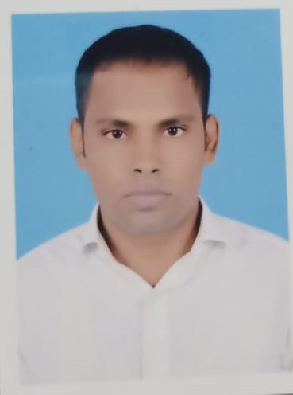
Addresse - 400017, Dharavi

MUMBAI, MAHARASHTRA

Mobile: 7870739904

Email – mdarshad191198@gmail.com

MD ARSHAD

Objective
Highly motivated individual Certified Digital Marketer and currently looking for Digital Marketing job opportunities.

DIGITAL MARKETING SKILLS
SEO, SMO, PPC CAMPAIGNS, CANVA DESIGNING
Working Experience
Total work experience- 1 year
1 Worked in Boston institute of analytics Company as a Digital Marketing executive 01-12- 2022 to 03 - 06 - 2023.
ROLES AND RESPONSIBILTIES where my job role was to generate the data science course leads through PPC and Facebook campaigns platforms like Facebook, google. I worked on social media. Where was I creating strategy, posting, increasing followers, and ready reports on a monthly basis .
3 Worked as a Promoter for Vodafone Private Limited in 2019 where I worked for 6 months .
Educational Qualification
1 Did matriculation in 2013 from Vidyapati High School Bisfi
2 Did intermediate in 2015 form C.M Collage Darbhanga
3 Completed my B.com in Account and Finance in 2019
4 Did certification in Digital Marketing in 2022.
Computer skills
Operating System : WINDOWS 10
Software Package : MS word and Excel

