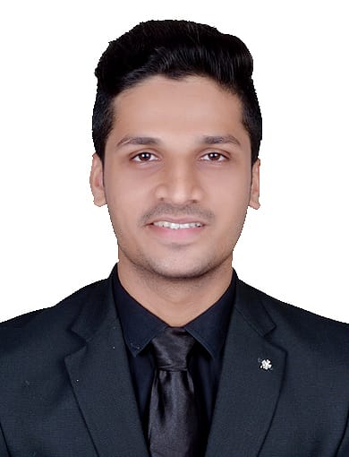

Mr. Aman Khan

▪ Email - [Amaankhan729@gmail.com](mailto:Amaankhan729@gmail.com)

▪ Contact - 9167617287

# Address

Jari Mari, Shamshuddin Nagar, Silver Sarc Society, Andheri Kurla Road, Mumbai-400072

# Profile

A goal-driven future Marketer with a niche for all things Digital. and To have a growth-oriented career, where I can contribute my knowledge and skills and enhance my career through continuous learning and teamwork.

# Work experience

Content Marketer – (1 Month)

Cabin Crew – (5 Months)

# Education

## Michael High School ▪ Mumbai ▪ India

### SSC

06/2005 – 05/2017

## Bhavans College ▪ Mumbai ▪ India

### HSC

07/2017 – 08/2019

## Bhavans college ▪ Mumbai ▪ India

Arts **(Bachelor’s In Mass Media)**

08/2019 – 05/2022

# Completed Digital Marketing ▪︎ Mumbai ▪︎ India

# *07/2022 – 10/2022*

# Skills

Customer Service

Good communication skills

Excellent interpersonal skills

Self-control

Flexibility

Physical stamina

Stress Management

Conflict Management

Time Management

Problem-solving

**Digital Marketing Certificate:-**

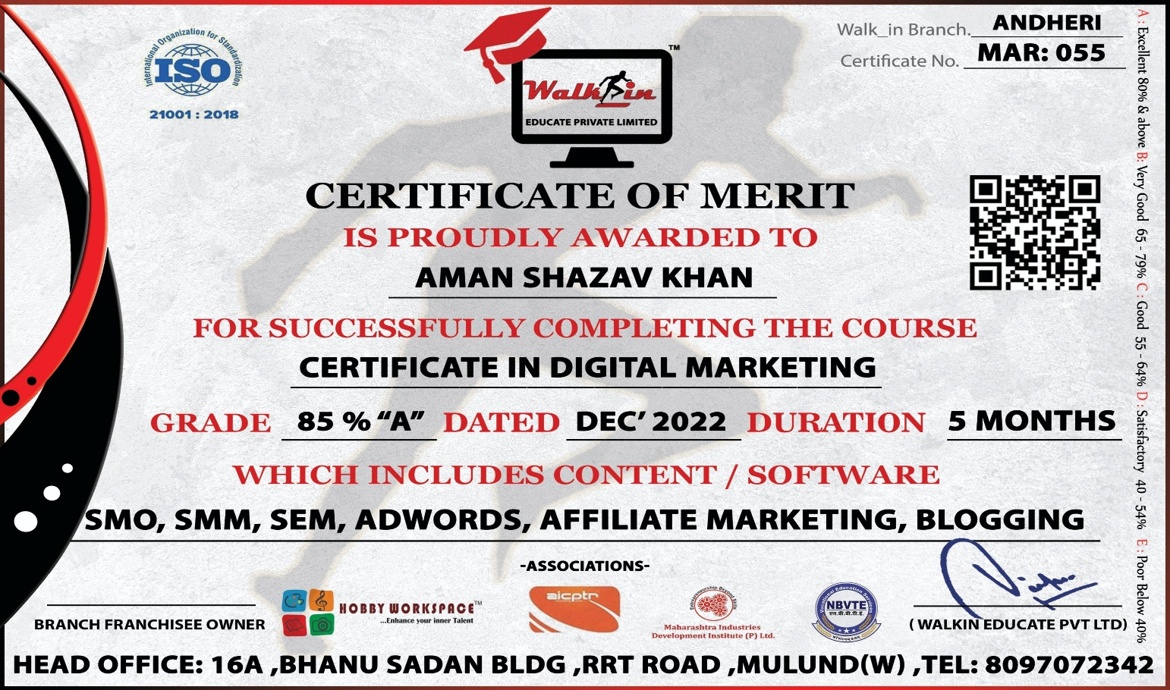

**Google Garage Certificate:-**

